Server Monitoring with Grafana Prometheus and Loki
Let's say we are backend developers working on a large, industry-scale application built using Node.js, Docker, and Kubernetes.
One night, some customers report that our application is running very slowly. Based on this feedback, we need to investigate what caused the failures or high latency.
The issue is that our application has many components, including servers, microservices, containers, and dynamically scaled instances. We check the servers, and everything appears to be working properly. Even Kubernetes autoscaling is functioning correctly, but we still have no idea what caused the slowdown last night.
To investigate such issues, we can set up a centralized monitoring system where all our microservices, services, servers, and containers send their metrics and logs. We can then track and visualize this information in one place to understand the system's health, CPU and RAM usage, request latency, and other potential issues.
For this, we use tools such as Grafana, Prometheus, and Loki. These are tools we should already have a basic understanding of.
Intuition
- Prometheus: Collects and stores metrics, such as CPU usage, memory consumption, and request latency.
- Grafana: Visualizes metrics through dashboards, charts, and graphs.
- Loki: Collects and stores logs so we can investigate application and infrastructure events.
Together, these tools help us monitor a large application and troubleshoot problems even when they occurred in the past.
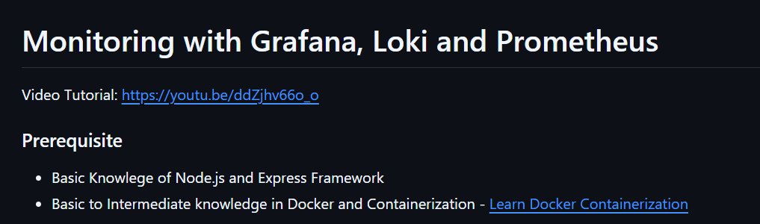

Explanation of Code:-
1. Import modules and configure the server
- require("express") — Imports Express.js, a framework for building web servers.
- require("./util") — Imports the doSomeHeavyTask() function from the local util.js file.
- express() — Creates an Express application instance and stores it in app.
- process.env.PORT — Reads the port number from environment variables.
- || 8000 — Uses port 8000 if the environment variable is not set to a truthy value.
2. Home route (/)
- app.get() — Registers a handler for HTTP GET requests.
- "/" — The root URL, such as http://localhost:8000/.
- req — The request object; contains information about the incoming request.
- res — The response object; used to send data back to the client.
- () => {} — An arrow function that runs when the route is matched.
Purpose: Handles requests to the home route. Its implementation is collapsed in the screenshot, so its exact behavior is not visible.
3. Slow route (/slow)
This endpoint executes a potentially time-consuming task and returns a JSON response.
A. Define the route
- app.get("/slow", ...) — Handles GET requests to /slow.
- async — Allows the callback to use await and makes it return a Promise.
- req and res — Represent the request and response.
B. Execute the task
- doSomeHeavyTask() — Calls the imported function that performs the task.
- await — Waits for the returned Promise to settle before continuing.
- const timeTaken — Stores the function's returned value, presumably the duration in milliseconds.
Example: If the function returns 2500, timeTaken becomes 2500.

C. Return a successful response
- res.json() — Sends a JSON response to the client.
- status — Indicates successful completion.
- `${timeTaken}` — Inserts the variable's value into the message using a template literal.
- return — Exits the route handler after sending the response.

D. Handle errors
- try — Contains code that might fail.
- catch (error) — Handles exceptions or rejected Promises from the awaited task.
- res.status(500) — Sets the HTTP status code to 500 (Internal Server Error).
- .json() — Sends the error response in JSON format.
4. Start the server
- app.listen() — Starts the HTTP server on the specified port.
- PORT — The port selected earlier.
- console.log() — Prints a message in the terminal.
- The callback executes when the server starts listening successfully.

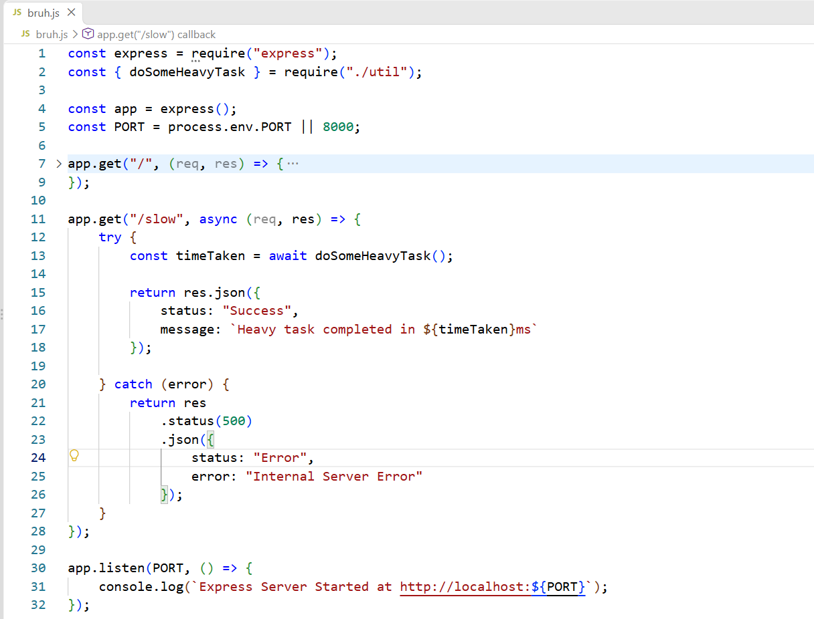

We can test whether the server is working using Postman, or simply open the localhost URL in a browser.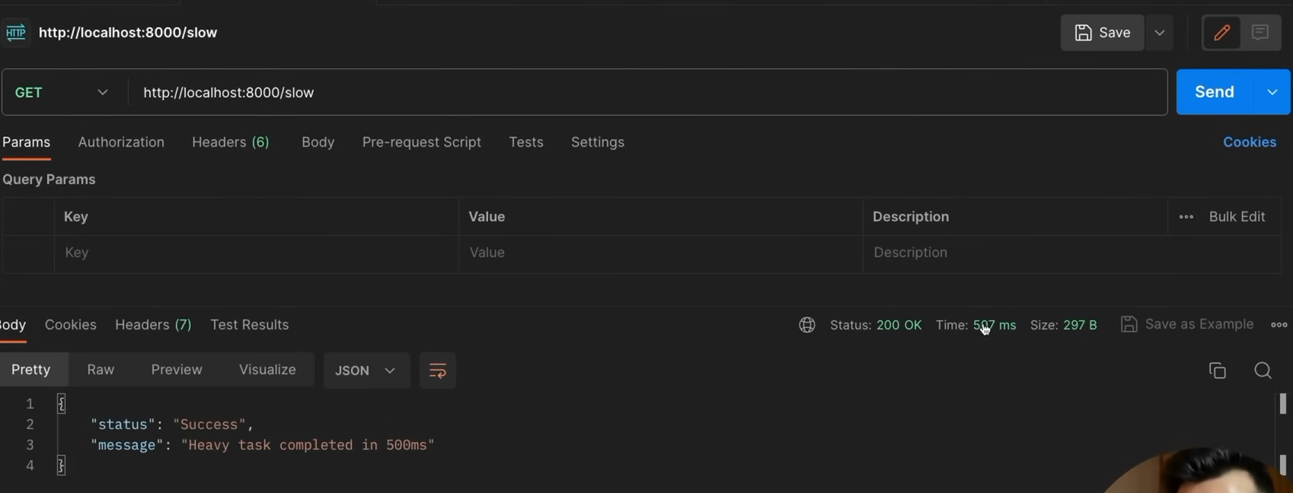

We track three main pillars for monitoring our system (often called the "Three Pillars of Observability"):
- Metrics: The numerical health data, like CPU usage, memory requests, and latency.
- Logs: The detailed records of runtime events. Since we have multiple servers, we push all these individual logs to a centralized service so we can search them in one place.
- Traces (Addition): You missed tracing! Traces track the exact journey of a single user request as it travels through different servers, databases, and microservices.

This is general architecture of what we were talking about.
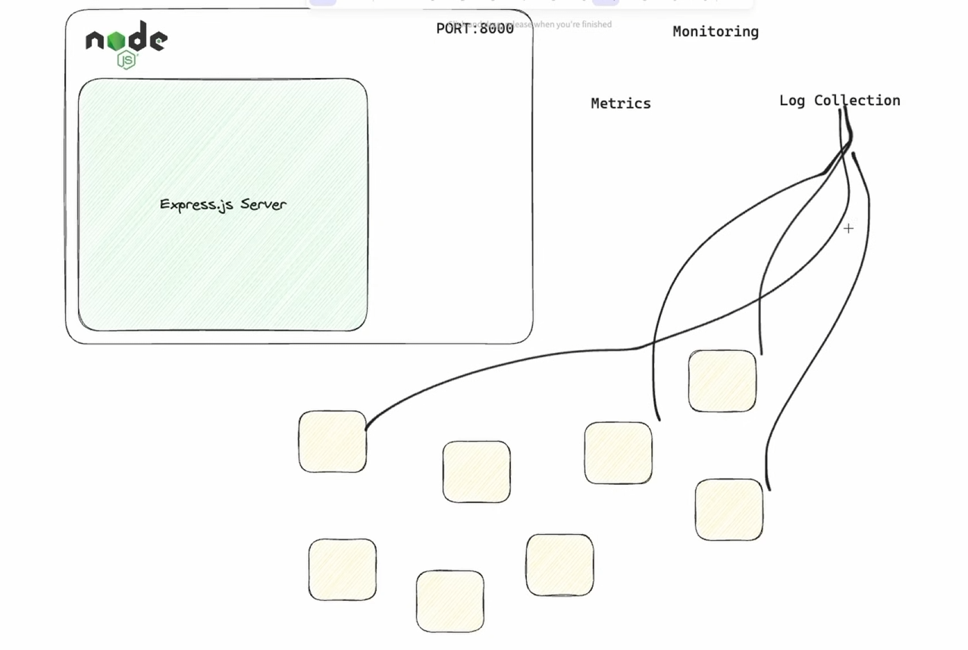

We collect metrics using Prometheus. Internally, inside our Node.js server, we install it using the command npm i prom-client and add it to our server file. This creates a Prometheus client that collects standard system metrics and any custom metrics we define.
Code Explanation :-
Prometheus Addition and Data Collection The Prometheus integration is handled primarily in the first few lines using the prom-client library.
- Line 2: Imports prom-client, which is the standard Prometheus client for Node.js.
- Lines 8-10: The code extracts collectDefaultMetrics from the client and executes it, passing in the default registry (client.register). This instructs the application to automatically begin collecting standard Node.js performance data in the background (such as CPU usage, memory consumption, and event loop lag) so it can eventually be scraped by a Prometheus server.
Code Section Breakdown
- Imports & Setup (Lines 1-6): Imports Express for the web server, prom-client for metrics, and a custom utility function doSomeHeavyTask. It initializes the Express app and sets the server to listen on port 8000 (or an environment-provided port).
- Metrics Initialization (Lines 8-10): Configures and starts the default Prometheus metric collection.
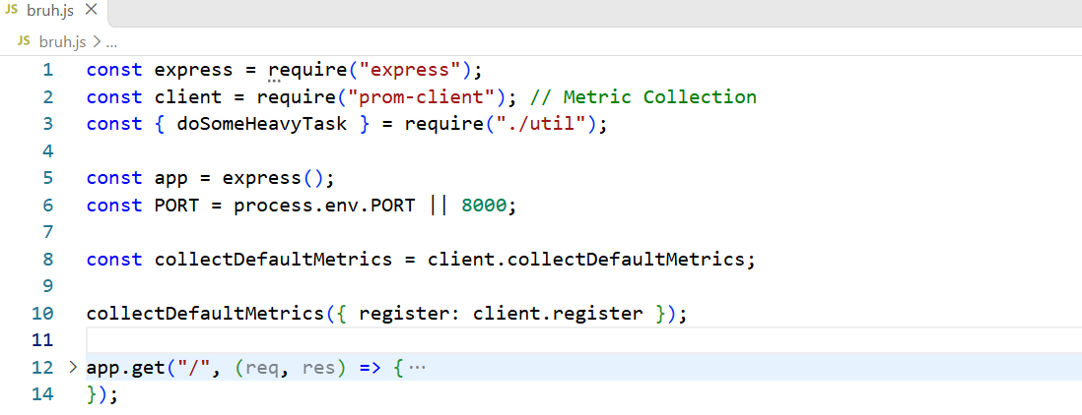
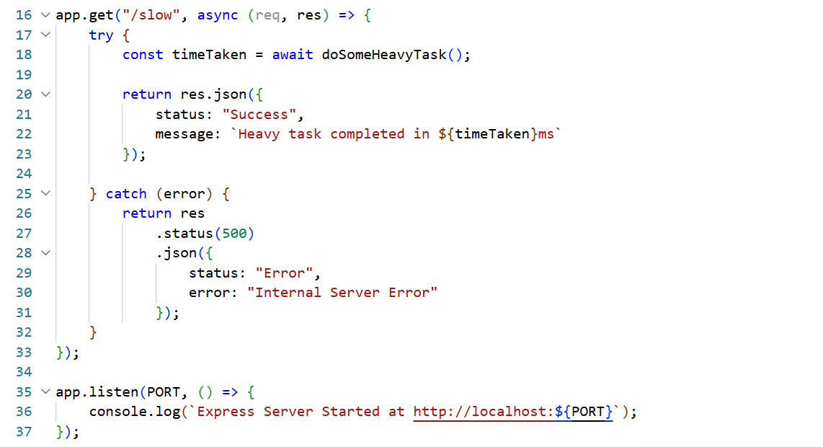
Even though prom-client is collecting data internally, to actually scrape, store, and view this data, we need to run a Prometheus server (typically by spinning up a Prometheus Docker container). Inside our Node.js code, we create a /metrics route (we can place this right below our existing /slow route) to output all the collected metric data. We also make sure our server is exposed on port 8000 so the Prometheus container can reach in and read it.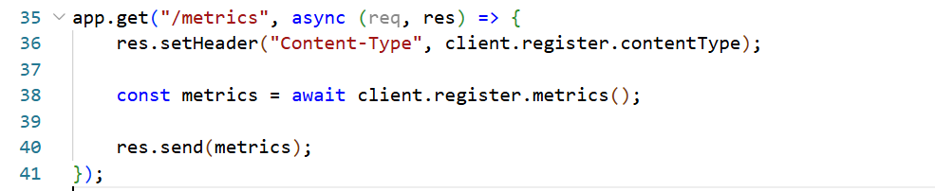

If we open the /metrics endpoint in Postman or our browser, we will see a giant wall of text.
Even though it looks like a bunch of logs, it is actually raw metric data formatted specifically for Prometheus. Some examples of the default metrics we will see include:
- process_cpu_user_seconds_total (How much CPU our server is using)
- nodejs_heap_size_used_bytes (How much RAM/memory our Node app is currently using)
- process_uptime_seconds (How long our server has been running without stopping)
- nodejs_eventloop_lag_seconds (How delayed our Node.js event loop is)
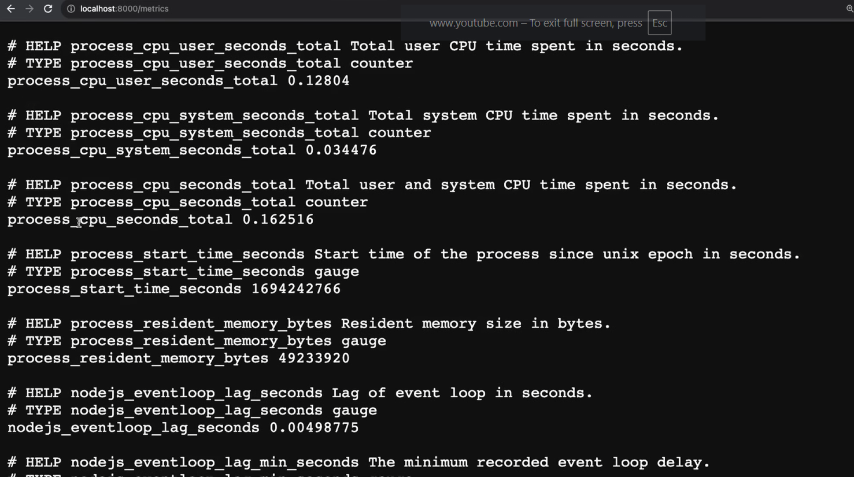
Since this raw metric data is hard for humans to read and visualize, our next step is to process it. With the data collection part done in our Node app, we now run an actual Prometheus server (which typically runs on port 9090). We configure this Prometheus server to periodically scrape (pull) the metrics from our app's /metrics endpoint (on port 8000). We also define the exact time interval for how often Prometheus should fetch this data (for example, every 5 or 15 seconds).
This is how we set up the actual Prometheus server. We create a file named prometheus-config.yml where we define a scrape interval of 4 seconds. We have the code ready for both this configuration file and the Docker command to run the container.
Inside the config file, we need to update the target address to point to our Node.js server (e.g., 172.16.101.183:8000). If we have multiple Node.js servers running, we can easily add all their addresses under the targets attribute.
For the Docker container, we provide the Prometheus image name (which will automatically download if it's our first time using it) and expose port 9090. We also use a volume mount by adding ./prometheus-config.yml:/etc/prometheus/prometheus.yml to the command. This is crucial because it takes our local config file and places it directly inside the Prometheus container so it knows what to do. Think of this as taking our custom handwritten instruction manual from our physical desk and permanently gluing it onto the dashboard of the health inspector's van (the container) so they can read it while driving.
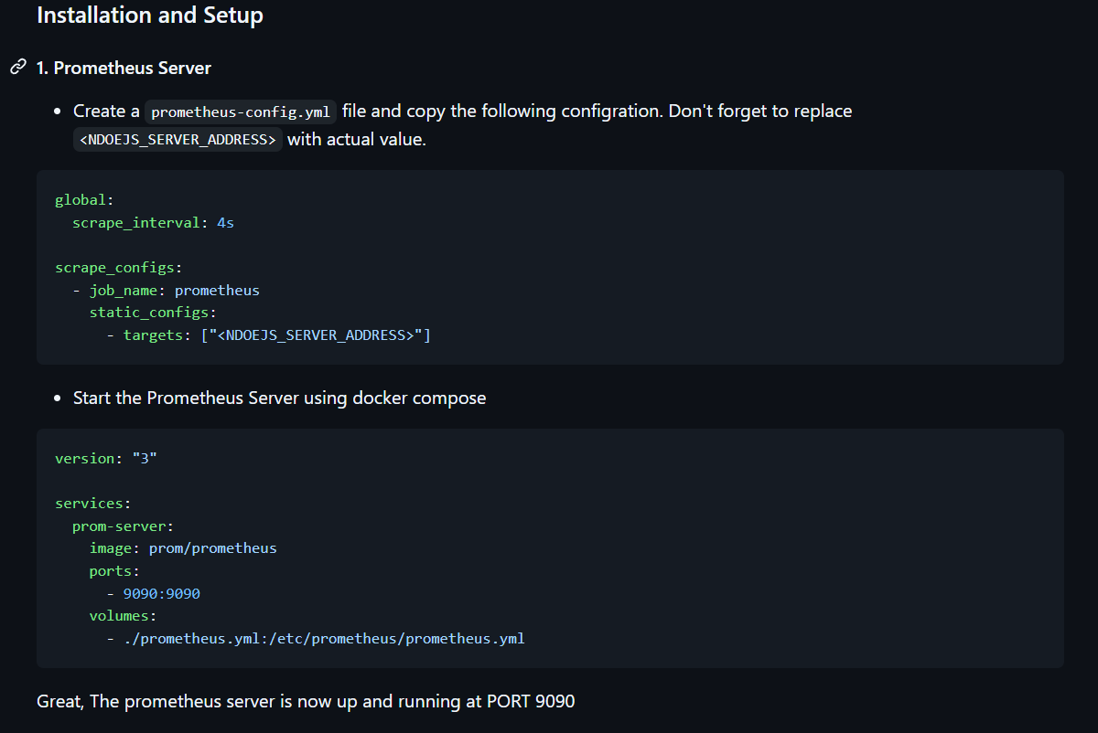
We can now start this setup using the docker-compose up command (or docker run). This will automatically download the Prometheus image if we don't have it yet, and then spin up the container. If we open localhost:9090 in our browser, we will see the Prometheus user interface. By navigating to Status > Targets in the top menu, we can see the Node.js server address we configured earlier. Notice that Prometheus automatically added /metrics to the end of our URL—this is its default behavior.
(Important Correction for our understanding): Once again, this server will scrape our metrics every 4 seconds, not our logs!
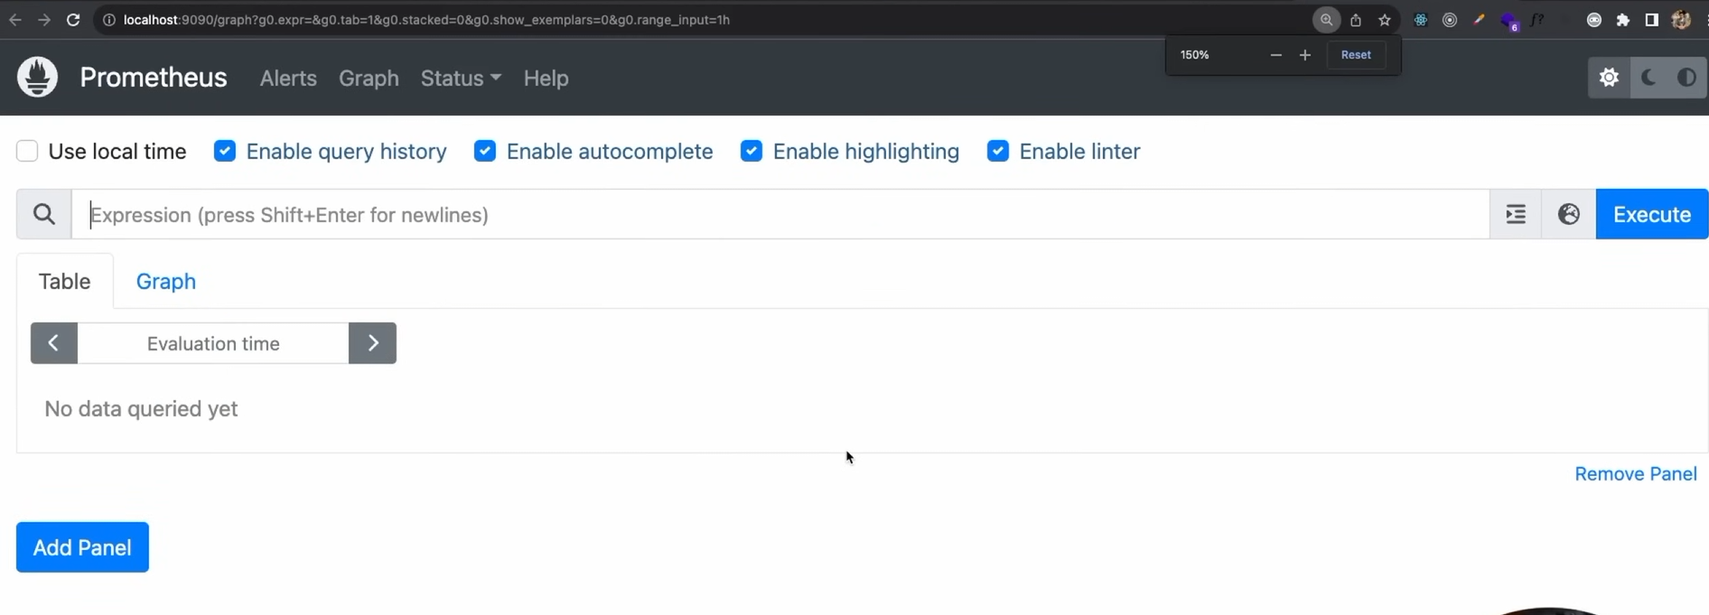
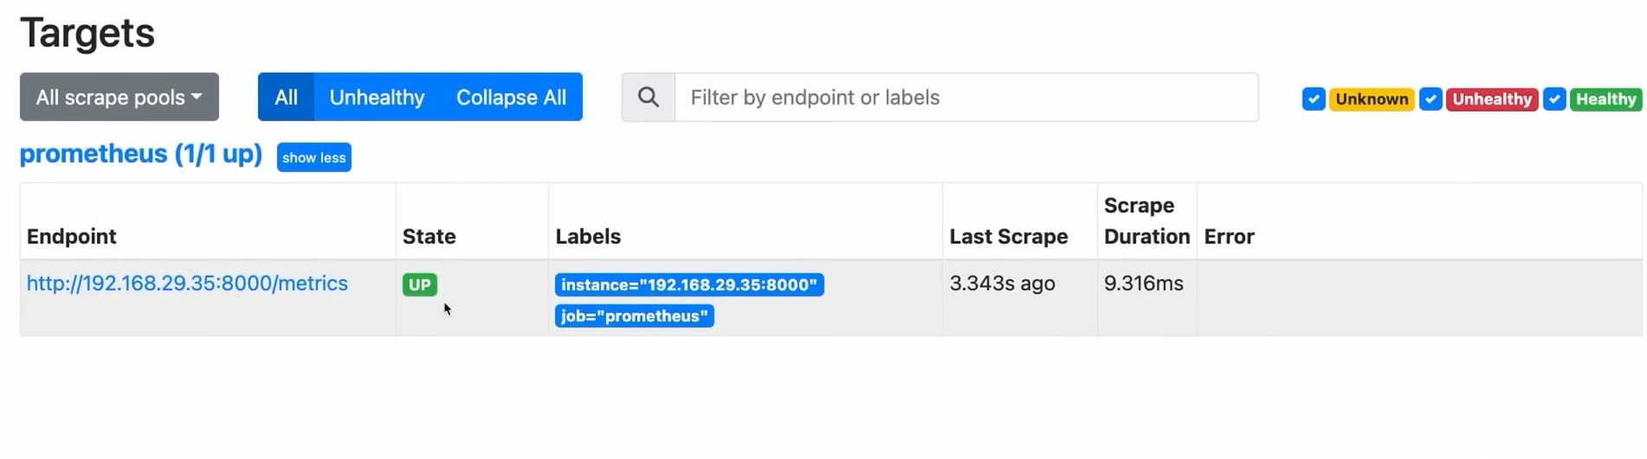

While the Prometheus dashboard is okay, its visual representation is still quite basic. This is where Grafana comes into the picture.
Grafana is an open-source visualization tool that runs on port 3000 by default. Instead of collecting data itself, Grafana connects directly to our Prometheus server, reads the stored data, and creates beautiful, customizable charts and dashboards for us. Just like with Prometheus, we can start Grafana using a Docker command (or by adding it to our Docker Compose setup), which will automatically download the Grafana image and spin up the container.
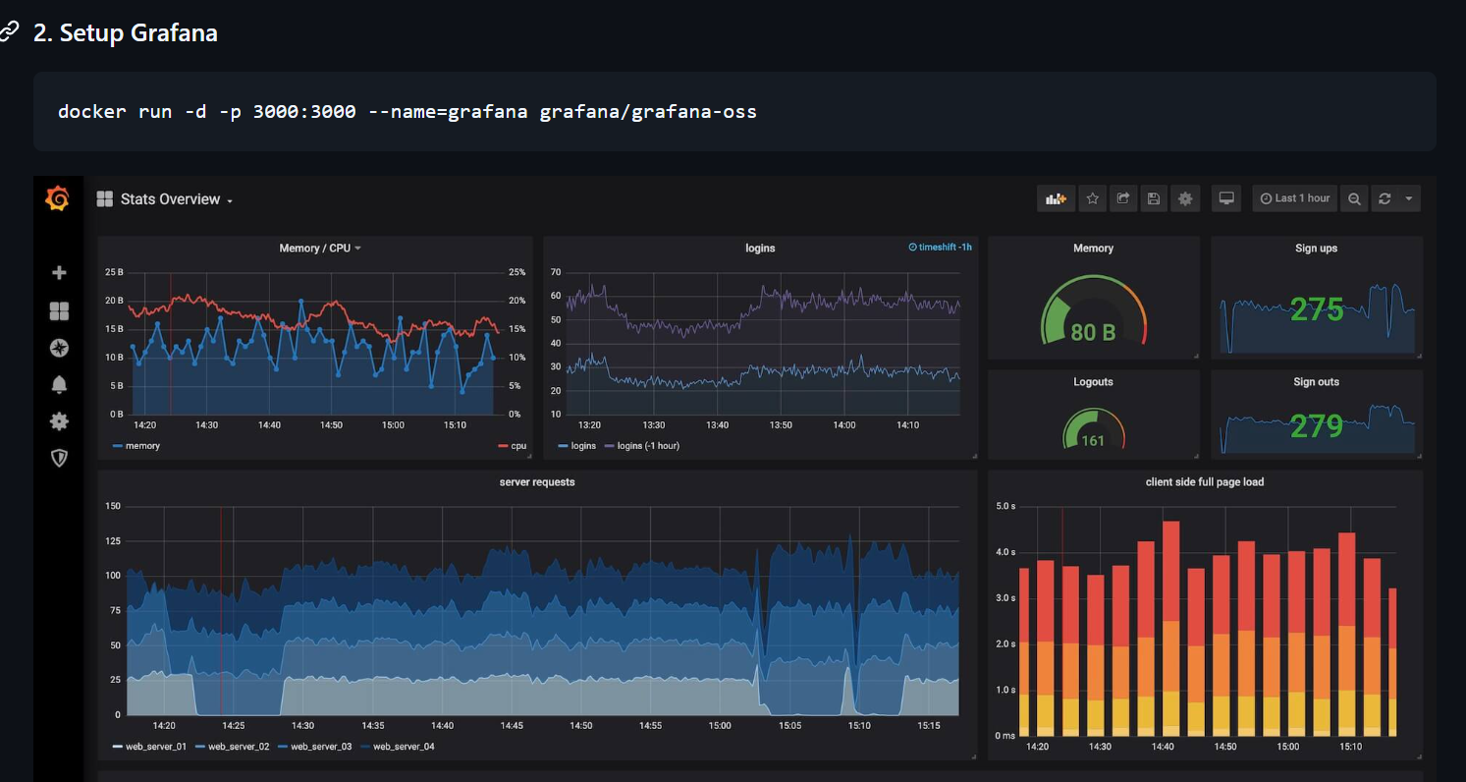
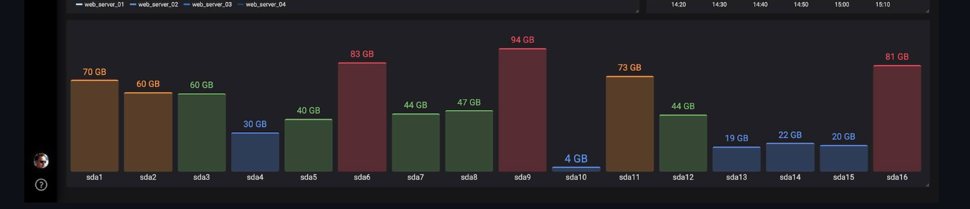

We can connect Grafana to many different data sources, including Prometheus, MongoDB, PostgreSQL, or even cloud services like AWS (by configuring the proper authentication).
To set this up, we open Grafana at localhost:3000 and click "Add your first data source." We select Prometheus from the list, enter its connection details, and click "Save & test" to ensure they are communicating.
Grafana creates dashboards, not databases! After testing the source, we click "Create your first dashboard" and then "Add visualization." We make sure Prometheus is selected as our data source, write our metric query, and run it. Grafana instantly generates a chart. We can easily change how this data looks by selecting different chart types on the right side, such as picking the "Stat" panel for a clean numerical display.
Data Sources: Grafana is like a brilliant, multilingual presenter. It doesn't just speak "Prometheus"—it can read reports from the PostgreSQL accounting team, the MongoDB sales team, or the AWS cloud team. Clicking "Save & test" is just the presenter doing a quick microphone check with those departments to ensure they can hear each other.
Creating a Dashboard: This is us setting up a blank, customizable layout on the giant projector screen.

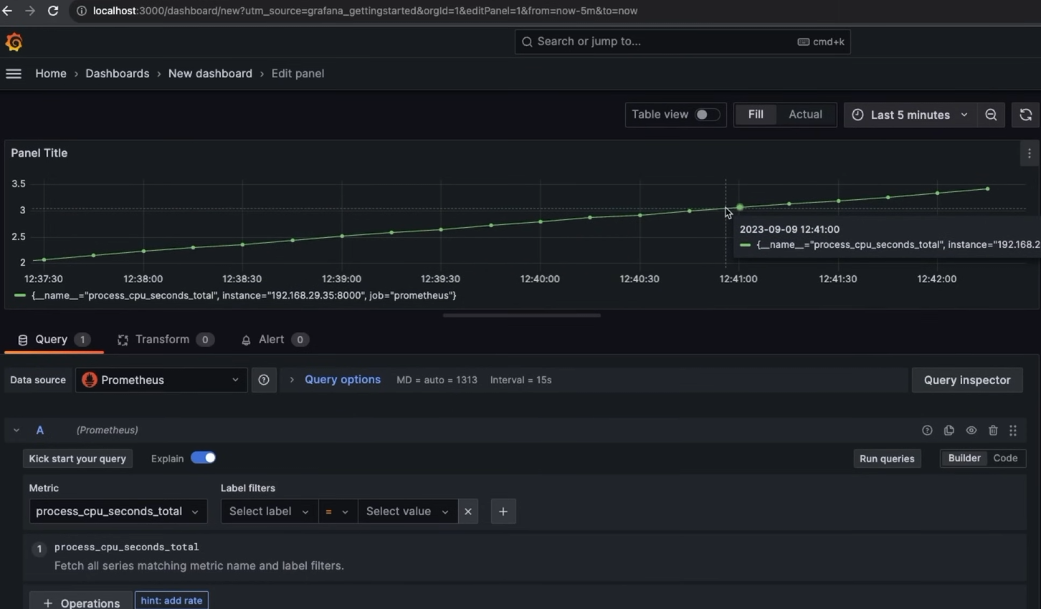
Building dashboards from scratch for every single metric can be time-consuming. Fortunately, we can use pre-made dashboards created by the community. To do this, we visit the official Grafana website (grafana.com/dashboards), search for a Node.js/Prometheus layout we like, and copy its unique Dashboard ID. Inside Grafana, instead of clicking "Add visualization," we go to the "+" menu and click "Import" (it is not called the "import library panel"). We simply paste the Dashboard ID we copied, tell it to use Prometheus as our data source, and click Load. Grafana will instantly generate a fully configured, professional dashboard for us.
Importing a Dashboard ID: This is like downloading a professionally designed PowerPoint template from the internet.
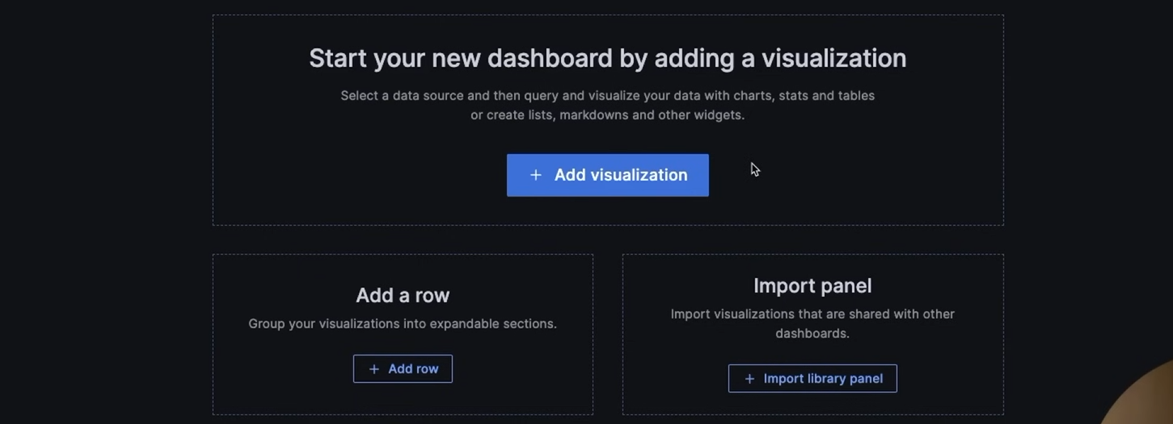
When setting up this imported dashboard, we confirm that our database type (Data Source) is set to Prometheus. It's important to remember that, by default, Prometheus only stores this metric data for 15 days.
Once the dashboard loads, we can see all these metrics beautifully visualized. By looking at these historical trends (like CPU spikes or memory leaks), we can make educated guesses and informed decisions about how our application is performing and when it might crash.
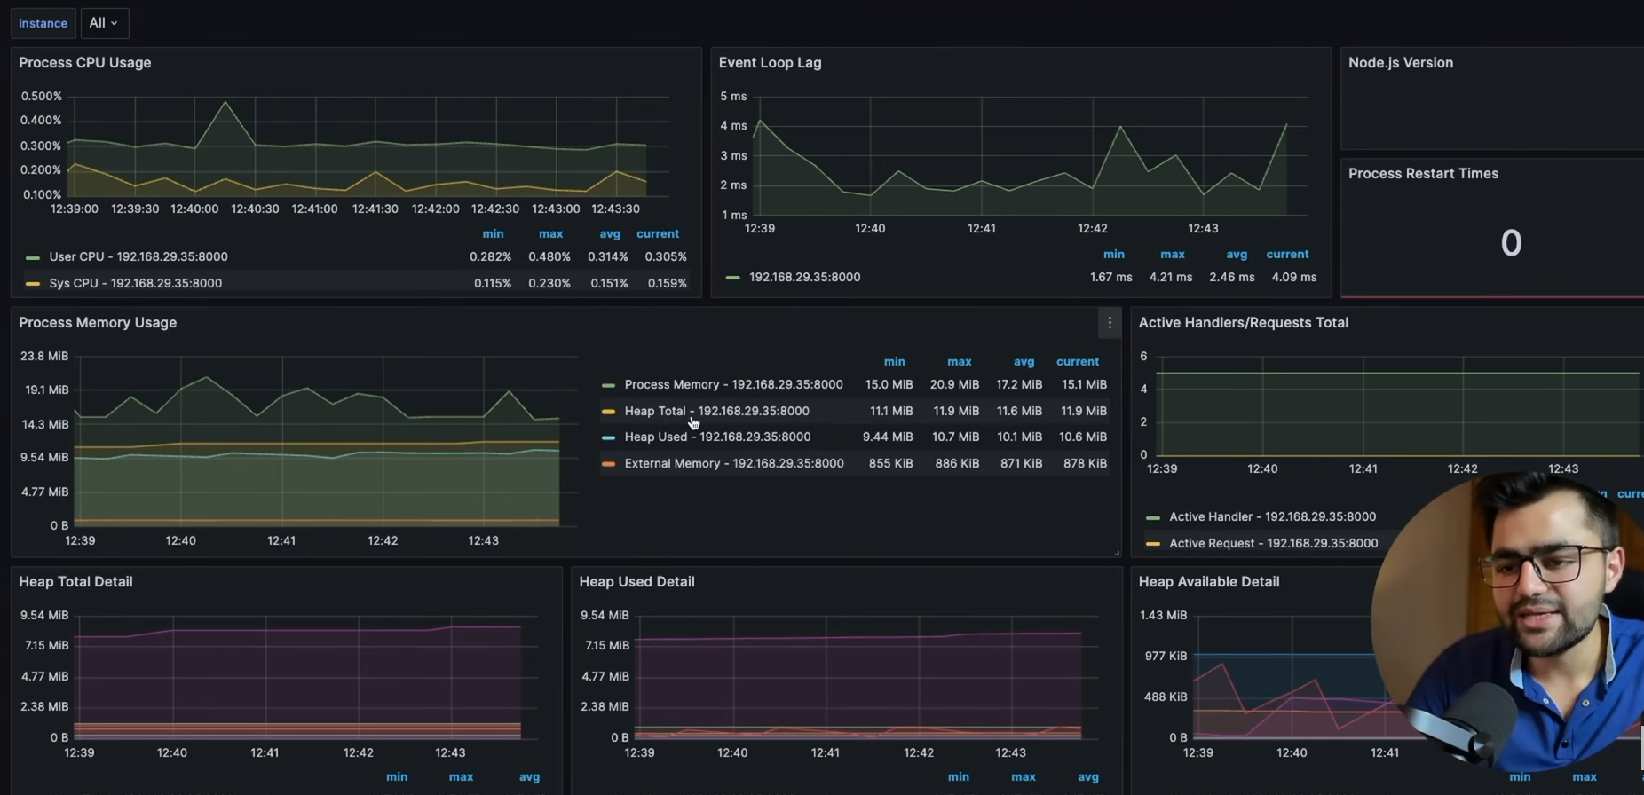
We can even create custom metrics, such as tracking exactly how much time a specific route takes to run (request latency).
We actually create and collect these custom metrics in our Node.js server code, not in Grafana! Grafana is just the visualization tool. To track this, we install an Express middleware package using npm i response-time. This package measures the duration of each incoming request, allowing us to send that specific timing data to our Prometheus client. Prometheus then scrapes it, and Grafana visualizes it.
Code:-
- Creating the Tracker (Lines 13-18): The code sets up a custom Prometheus metric called a "Histogram" named reqResTime. Think of this Histogram as a sorting system with predefined time buckets (1ms, 50ms, 100ms, up to 2000ms). It also defines labelNames (method, route, status_code), which act like sticky notes attached to each measurement so you can filter your data later (for example, isolating all "GET" requests or checking the speeds of just the "500" errors).
- Running the Stopwatch (Lines 21-30): The app.use(responseTime(...)) block acts as an automatic stopwatch for every single request your server receives. When the server finishes processing a request and sends a response, this block grabs the total time it took. It then attaches the specific tags for that exact request (the method used, the route visited, and the status code returned) and drops that recorded time into the correct time bucket using .observe(time).
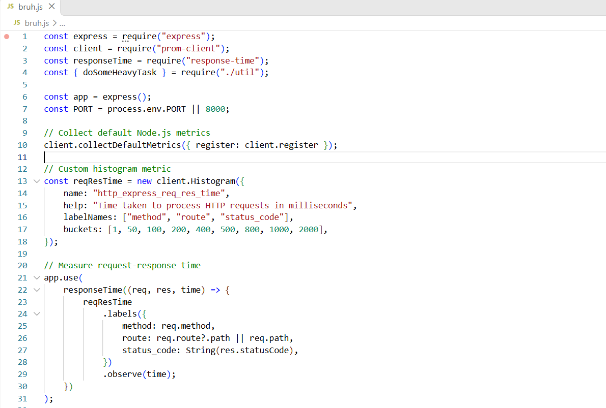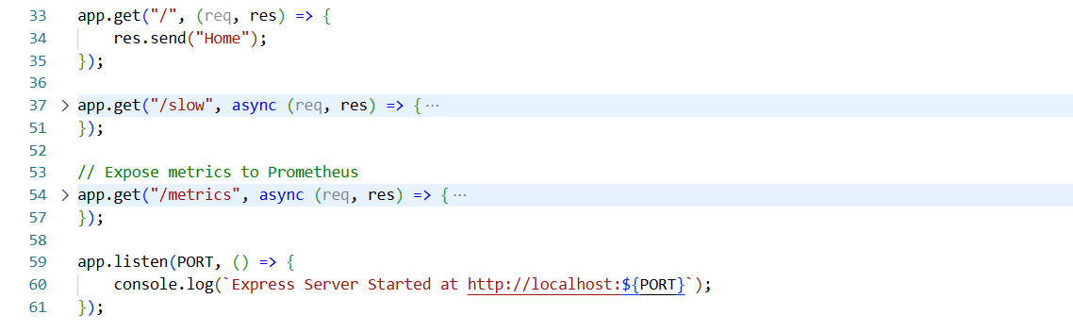

To visualize this custom metric in Grafana, we click Add > Visualization and enter our metric's name (e.g., http_express_req_res_time) into the query builder. This name must exactly match the custom name we defined earlier in our Node.js code. By running this query and filtering it using different parameters (called "labels" in Prometheus, such as the route path or HTTP method), we can isolate the data to quickly identify and troubleshoot performance issues on any specific route.
Using Parameters (Labels): Instead of just looking at the average speed of the entire factory, parameters let us filter the data. It's like telling the presenter, "Only show me the stopwatch times for Assembly Line B (the /slow route) during the morning shift (GET requests)." This lets us instantly see exactly which specific machine is causing a bottleneck, rather than guessing where the slowdown is happening.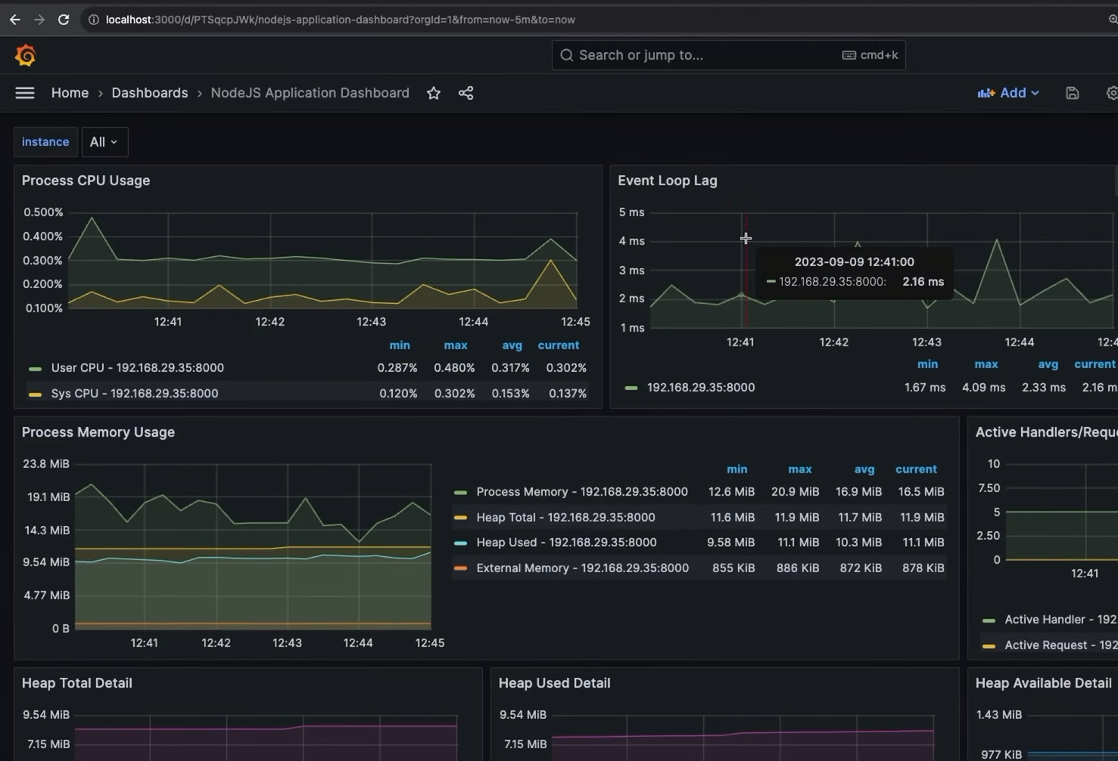

Now for log collection, we use a tool called Grafana Loki, which runs on port 3100 by default.
Loki doesn't actively "pull" logs from our server. Instead, our Node.js server pushes the logs to Loki. To do this, we install the logging packages winston and winston-loki (npm i winston winston-loki). Winston formats our logs, and winston-loki ships them directly to the Loki server. Once Loki has the logs, we simply connect Loki as a new data source inside Grafana so we can search and read them.
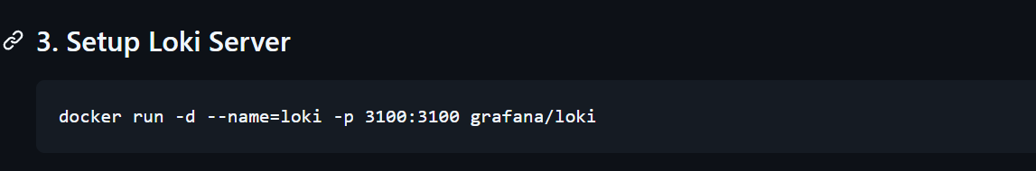
Code:-
1. Module Imports (Lines 4–5)
- winston: A logging framework for Node.js that handles structuring and formatting log messages.
- winston-loki: A transport plugin that connects Winston directly to Grafana Loki.
2. Transport & Logger Configuration (Lines 7–15)
- options Object (Lines 7–13): Configures a LokiTransport pointing to [http://127.0.0.1:3100](http://127.0.0.1:3100). This tells Winston to batch log entries and push them over HTTP to the running Loki instance at port 3100.
- createLogger(options) (Line 15): Instantiates the global logger instance using the defined Loki options.
3. Emitting Logs in Express Routes (Lines 46, 55, 63)
Instead of standard console.log(), the application now uses the Loki logger inside request handlers:
- logger.info(...) (Lines 46 & 55): Sends informational logs (e.g., "Req came on / route" or "Req came on /slow route") whenever endpoints are hit.
- logger.error(...) (Line 63): Sends error logs containing error.message whenever an exception is caught in the /slow route.
How It Works Under the Hood
- A request hits an Express endpoint.
- The endpoint calls logger.info() or logger.error().
- Winston passes the log message to LokiTransport.
- LokiTransport streams the logs asynchronously over HTTP to [http://127.0.0.1:3100](http://127.0.0.1:3100).
- Grafana can then query these logs alongside your Prometheus metrics for full system observability.
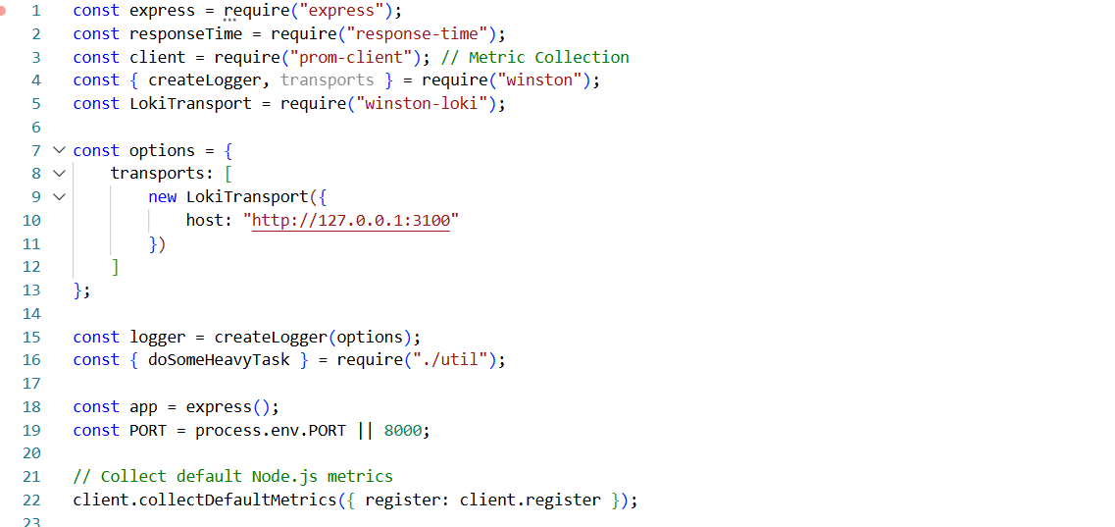
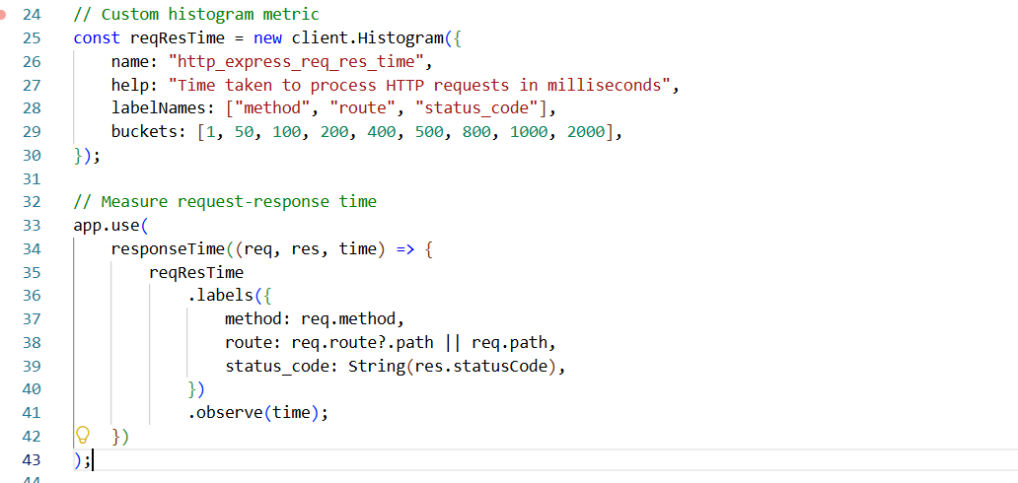
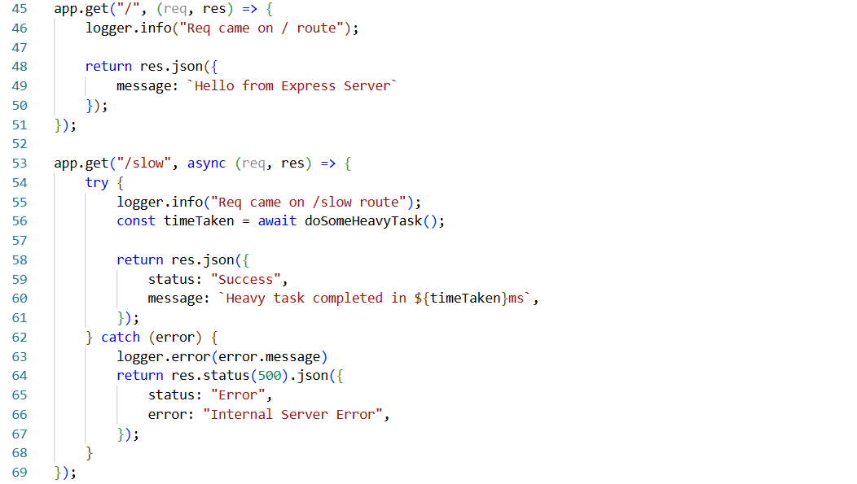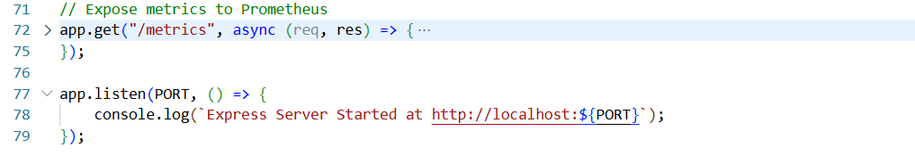
Now, inside Grafana, we add Loki as our new data source. Just like we did for Prometheus, we need to provide its connection URL so Grafana knows where to find the data. However, instead of using localhost, we use our server's actual IPv4 address along with Loki's port number (for example, http://<our-ipv4-address>:3100).
We use the IPv4 address instead of localhost because, depending on how our Docker containers or servers are set up, Grafana might be running in an isolated environment. If we tell it to look at localhost, it will only look inside its own container and fail to find Loki.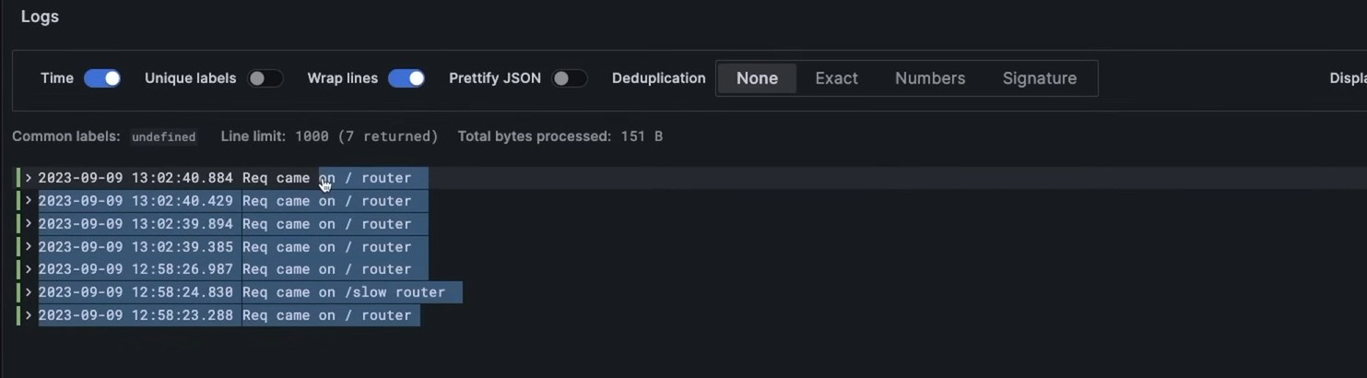

Inside Grafana, we also need to filter our logs by their severity level, selecting whether we want to view routine info logs or critical error logs.
Filtering in Grafana: Without filtering, the presenter reads every single routine diary entry to us, which makes it impossible to spot actual problems. Filtering is simply us telling the presenter, "Skip the boring everyday stuff and only put the red emergency reports on the projector so we can see what's broken."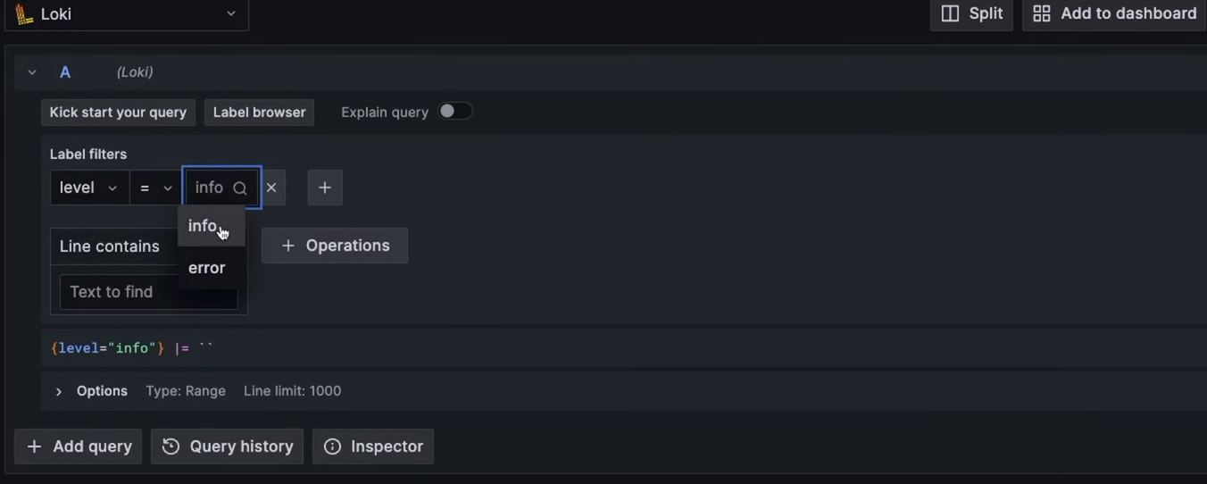
Inside Grafana, we can create two separate panels using Loki as the data source—naming one "Info Logs" and the other "Error Logs." While a "Table" visualization works, Grafana actually has a dedicated "Logs" visualization type that is best for this. We must use one of these text-based formats instead of a chart like "Time series," because logs are discrete text records, not continuous numerical data points.
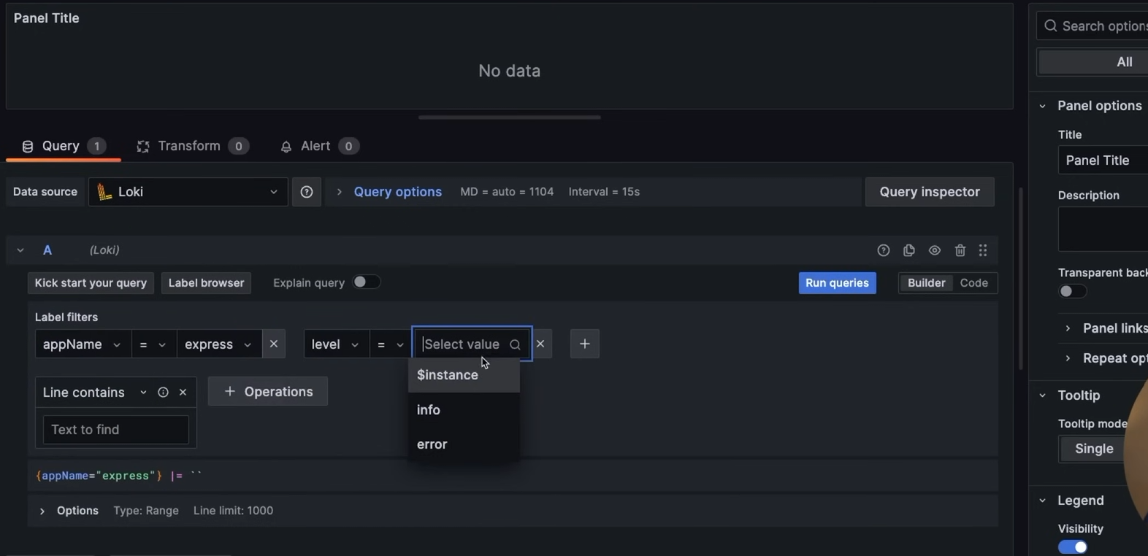
With everything connected, we can finally see specific issues, such as "Not Found" errors, directly in Grafana. This solves our visibility problem—if the server crashes in the middle of the night, we can now check the logs the next morning to see exactly what went wrong.
When looking at our "Total Requests" metric, the number might seem unusually high. This happens because every single time the Prometheus server scrapes our /metrics endpoint, our Node.js server counts it as an incoming HTTP request.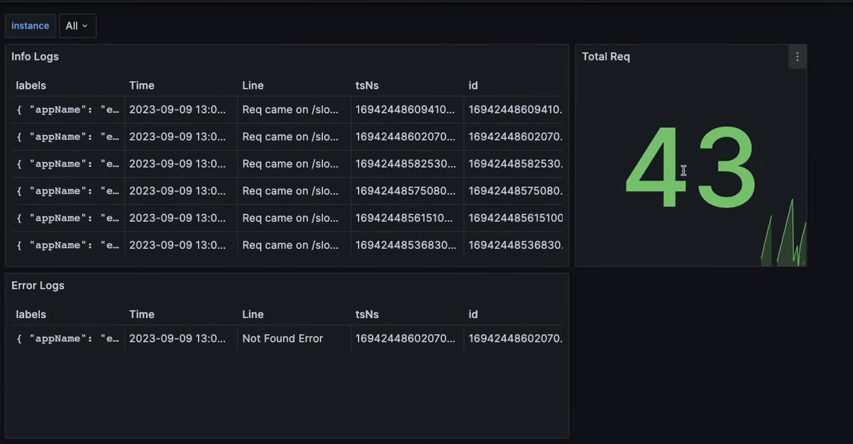
To summarize our final monitoring stack: we use Prometheus for metric collection, Loki for log collection, and Grafana for overall visualization, allowing us to build powerful dashboards that combine both data sources into one view.

